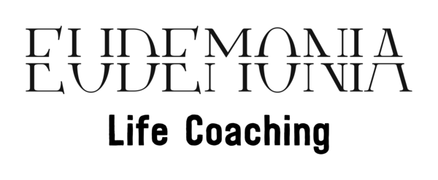

RIGHT TO ERASURE

You are entitled to request us to erase any personal data we hold about you under EU General Data Protection Regulation (GDPR).
We will do our best to respond promptly and in any event within one month of the following:
- Our receipt of your written request; or
- Our receipt of any further information we may ask you to provide to enable us to comply with your request, whichever happens to be later.
The information you supply in this form will only be used for the purposes of identifying the personal data you are requesting that we erase and responding to your request. You are not obliged to complete this form to make a request, but doing so will make it easier for us to process your request quickly.

SECTION 1: Details of the person requesting information
Full name:

Address:
Contact telephone number:
Email address:

SECTION 2: Are you the data subject?

Please tick (X) the appropriate box and read the instructions which follow it.

YES: I am the data subject. I enclose proof of my identity (see below). (Please go to Section 4)
NO: I am acting on behalf of the data subject. I have enclosed the data subject’s written authority and proof of the data subject’s identity and my own identity (see below). (Please go to Section 3)

To ensure we are erasing data of the right person we require you to provide us with proof of your identity and of your address. Please supply us with a photocopy or scanned image (do not send the originals) of one or both of the following:
1) Proof of Identity
Passport, photo driver’s license, national identity card, birth certificate.
2) Proof of Address
Utility bill, bank statement, credit card statement (no more than 3 months old); current driver’s license;
If we are not satisfied you are who you claim to be, we reserve the right to refuse to grant your request.

SECTION 3: Details of the data subject (if different from section 1)
Full name:
Address:
Contact telephone number:
Email address:

SECTION 4: Reason for erasure request
Given the sensitive nature of erasing personal data, GDPR Article 17(1) requires certain conditions to be met before a request may be considered. Please supply us with the reason you wish your data to be erased and please attach any justifying documents to this one.
Please tick (X) the appropriate box:
You feel your personal data is no longer necessary for the purposes for which we originally collected it.
You no longer consent to our processing of your personal data.
You object to our processing of your personal data as is your right under Article 21 of the GDPR.
You feel your personal data has been unlawfully processed.
You feel we are subject to a legal obligation of the EU or Member State that requires the erasure of your personal data.
You are a child, you represent a child, or you were a child at the time of the data processing and you feel your personal data was used to offer you information society services.

SECTION 5: What information do you wish to erase?
Please describe the information you wish to erase. Please provide any relevant details you think will help us to identify the information. Providing the URL for each link you wish to be removed would be helpful.
Also, please explain, if it is not abundantly clear, why the linked page is about you or the person you are representing on this form.
Please note that. In certain circumstances, where erasure would adversely affect the freedom of expression, contradict a legal obligation, act against the public interest in the area of public health, act against the public interest in the area of scientific or historical research, or prohibit the establishment of a legal defense or exercise of other legal claims, we may not be able to erase the information you requested in accordance with article 17(3) of the GDPR. In such cases you will be informed promptly and given full reasons for that decision.
While in most cases we will be happy to erase the personal data you request, we nevertheless reserve the right, in accordance with Article 12(5) of the GDPR, to charge a fee or refuse the request if it is considered to be “manifestly unfounded or excessive.” However we will make every effort to provide you with the erasure of your personal data if suitable.

SECTION 6: Declaration
Please note that any attempt to mislead may result in prosecution.
I confirm that I have read and understood the terms of this subject access form and certify that the information given in this application to ______________ is true. I understand that it is necessary for ________________ to confirm my/the data subject’s identity and it may be necessary to obtain more detailed information in order to locate the correct personal data.
Signed: ………………………………………… Date: ……………..
Documents which must accompany this application:
- Evidence of your identity (see section 2)
- Evidence of the data subject’s identity (if different from above)
- Authorization from the data subject to act on their behalf (if applicable)
- Justification for erasure of data (see section 4)

