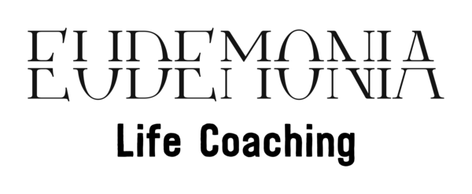

PRIVACY POLICY

Eudemonia Coaching ("us", "we", or "our") operates www.eudemonia-coaching.com (the "Site"). This page informs you of our policies regarding the collection, use and disclosure of Personal Information we receive from users of the Site.

We use your Personal Information only for providing and improving the Site. By using the Site, you agree to the collection and use of information in accordance with this policy.

Information Collection And Use

While using our Site, we may ask you to provide us with certain personally identifiable information that can be used to contact or identify you. Personally identifiable information may include, but is not limited to your name ("Personal Information"), email address and phone number.

Video and Audio Recordings
All video sessions are automatically recorded via Zoom and later safely stored by Eudemonia Coaching Ltd. In the case of videos and audio recordings of client sessions prior informed consent is obtained from the client, at the commencement of a contract, as per its terms and conditions. The signed consent acquired during the contractual agreement is stored separately from the recording in order to preserve confidentiality.

The Purpose of Record Keeping
- To improve continuity between sessions.
- To provide a record for the use of the Coach, and in exceptional cases, the client.
- To facilitate assessment, planning and evaluation of progress.
- To allow the collection of basic statistical information for the purposes of audit where coaching is provided within an organisational context. This may include before and after outcome measures.
- To provide a record that is clear, complete and up to date.

Log Data

Like many site operators, we collect information that your browser sends whenever you visit our Site ("Log Data").

This Log Data may include information such as your computer's Internet Protocol ("IP") address, browser type, browser version, the pages of our Site that you visit, the time and date of your visit, the time spent on those pages and other statistics.

In addition, we may use third party services such as Google Analytics that collect, monitor and analyze this .

Communications

We may use your Personal Information to contact you with newsletters, marketing or promotional materials and other information of the same nature.

Cookies

Cookies are files with a small amount of data, which may include an anonymous unique identifier. Cookies are sent to your browser from a web site and stored on your computer's hard drive.

Like many sites, we use "cookies" to collect information. You can instruct your browser to refuse all cookies or to indicate when a cookie is being sent. However, if you do not accept cookies, you may not be able to use some portions of our Site.

Security
The security of your personal information is of utmost importance to us. Any relevant personal data and records are kept securely locked for a period of six (plus one additional ‘safety’) years after the last contact with the client.
Paper records are always disposed of as carefully as they are stored; records are shredded or incinerated to ensure their destruction and illegibility.
It is the duty of Eudemonia Coaching to ensure that the data is kept securely so that unauthorized access and identification of the data subject do not occur. All electronic data copies are made secure from access by others and we maintain responsibility for the below:
- That information is effectively protected against access by unauthorized third parties.
- The prevention of improper disclosure of information when stored, transmitted, received or in its disposal.
- That information is not unlawfully transmitted/shared to anyone outside the organization.

Changes To This Privacy Policy

This Privacy Policy is effective as of July 2020 and will remain in effect except with respect to any changes in its provisions in the future, which will be in effect immediately after being posted on this page.

We reserve the right to update or change our Privacy Policy at any time and you should check this Privacy Policy periodically. Your continued use of the Service after we post any modifications to the Privacy Policy on this page will constitute your acknowledgment of the modifications and your consent to abide and be bound by the modified Privacy Policy.

If we make any material changes to this Privacy Policy, we will notify you either through the email address you have provided us, or by placing a prominent notice on our website.

